Testing Plan

Prototype testing of Hacker House Version 3:

Testing Questions | Yes/No | Notes/Evidence
Does Version 3 open correctly and display the main menu? | Yes | 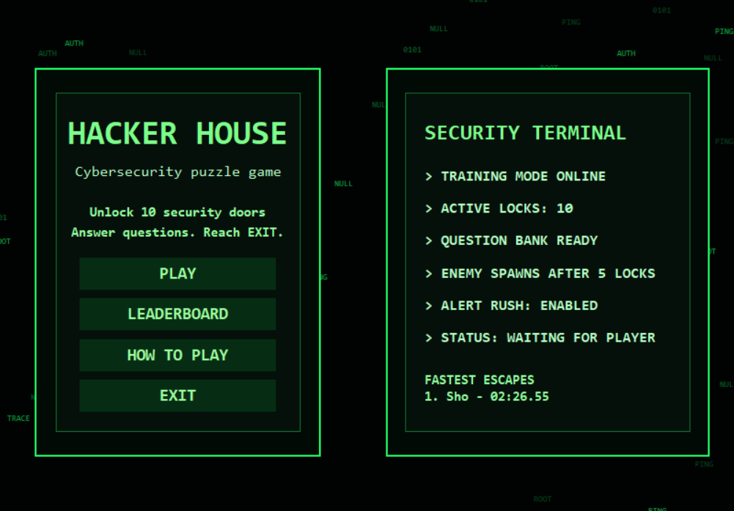
Does player-name entry work correctly? | Yes | 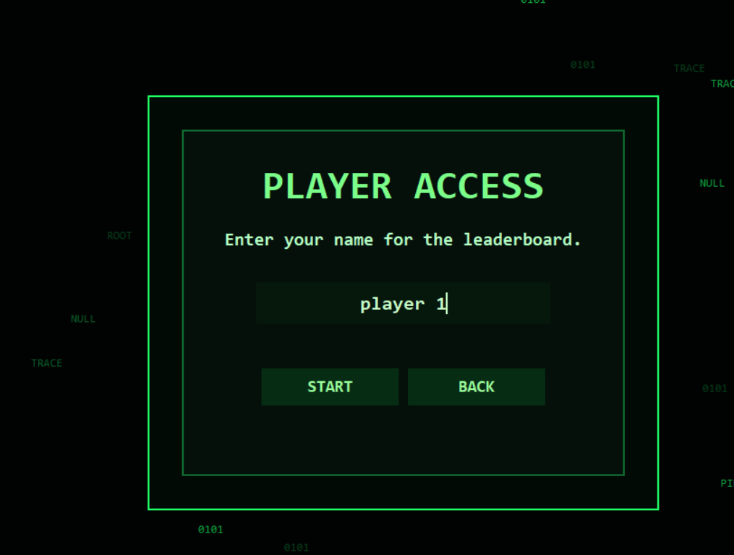
Do the menu screens and navigation controls work? | Yes | 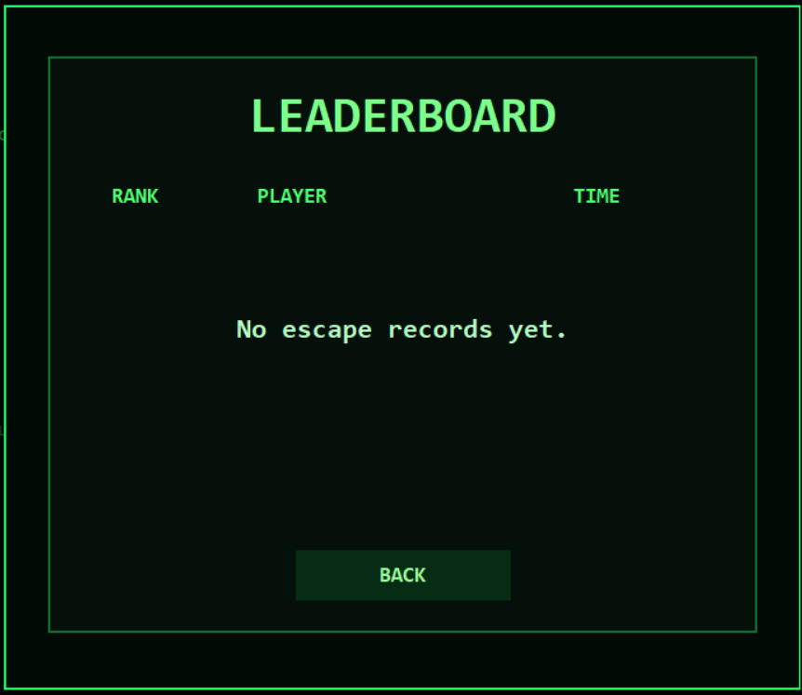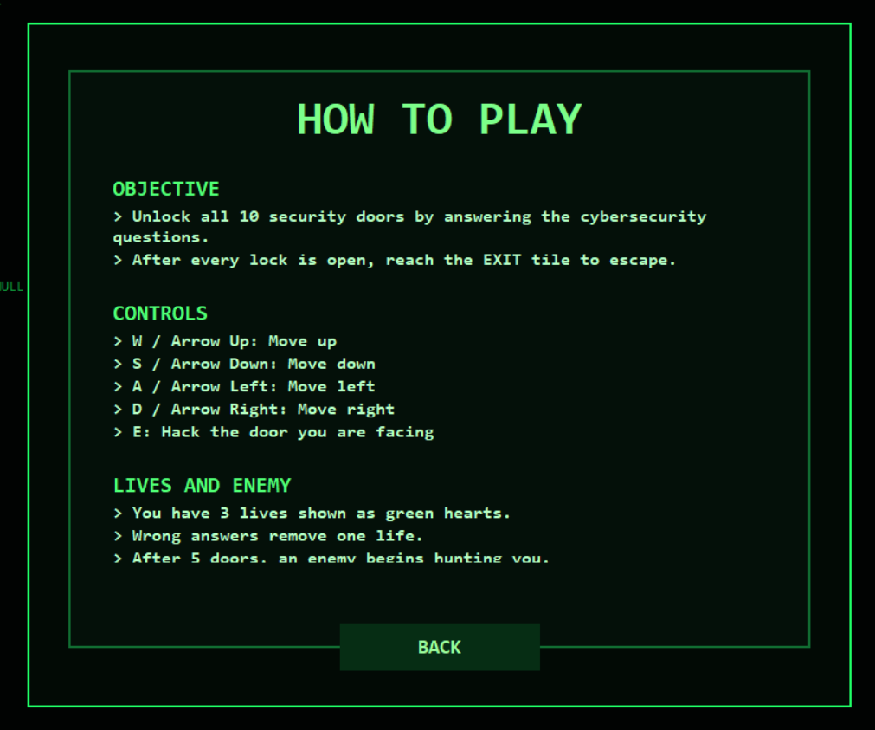
Do movement, facing and collision work correctly? | Yes | You can’t walk through walls and pressing movement keys can change where the character if facing  
Can the player open and cancel a door quiz? | Yes | Pressing cancel removes the quiz screen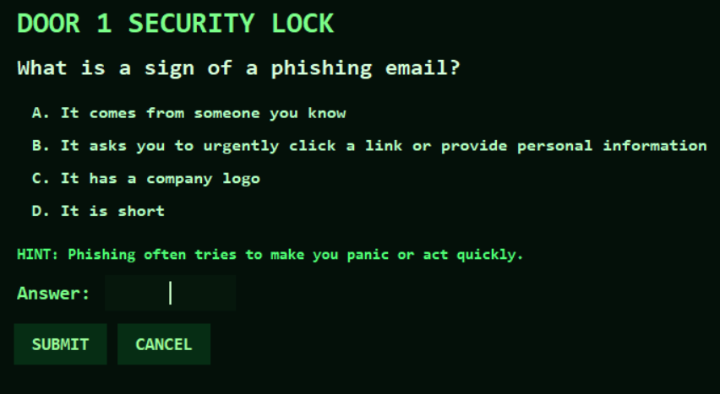
Are correct quiz answers accepted? | Yes | The door unlocked after putting the correct answer 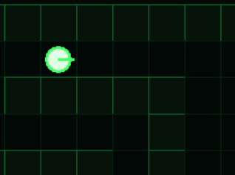
Do wrong or blank answers remove one life and show feedback? | Yes | 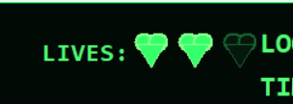
Does the enemy appear at the correct point in the game? | Yes | Enemy appears after 5 questions are correctly answered or when the player loses all the lives  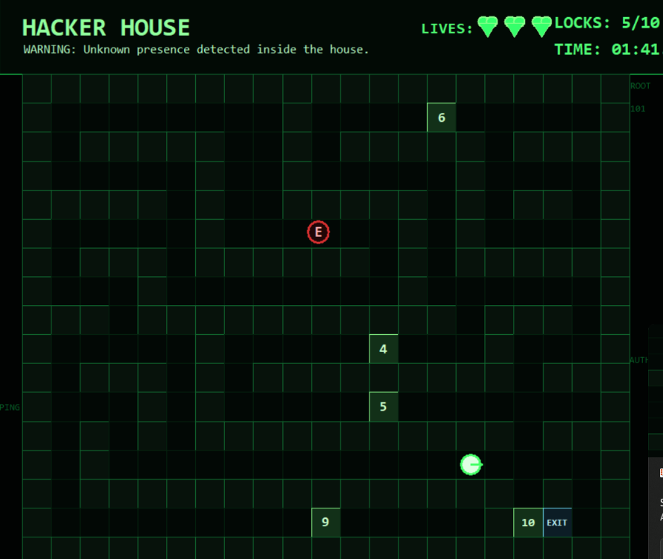
Does the enemy investigate later unlocked doors? | Yes | 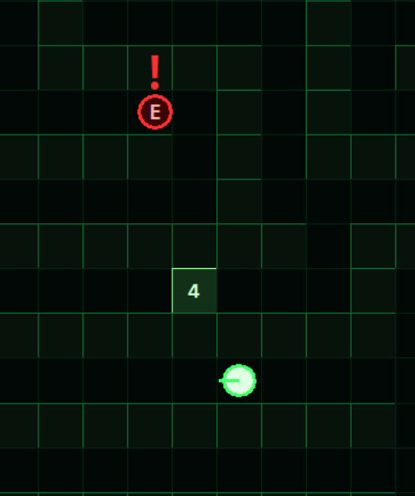
Can the enemy navigate and capture the player correctly? | No | It can navigate the maze well, but after investigating the gate recently unlocked it stays stationary
Does losing all three lives produce the correct game-over flow? | Yes | Enemy locks on your location and captures you.  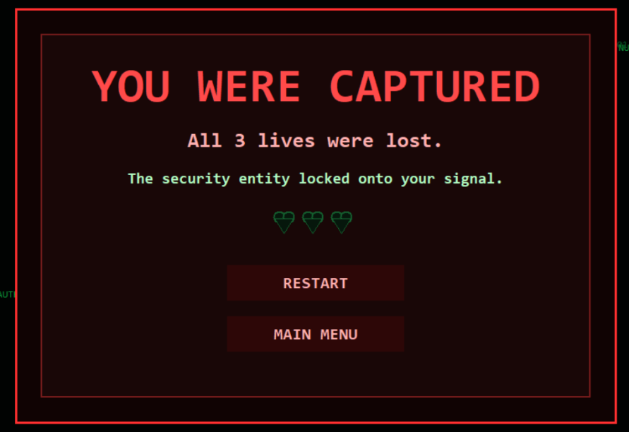
Does the interface resize and use fullscreen correctly? | Yes | 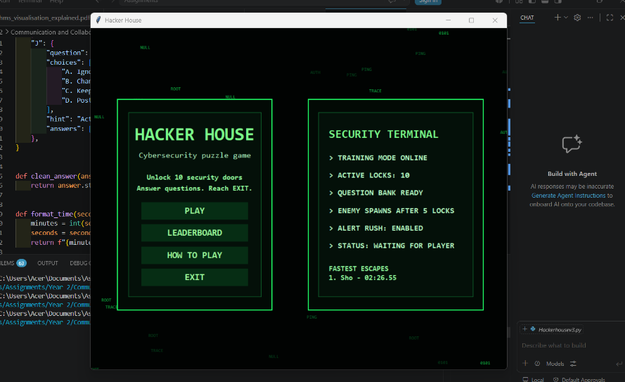  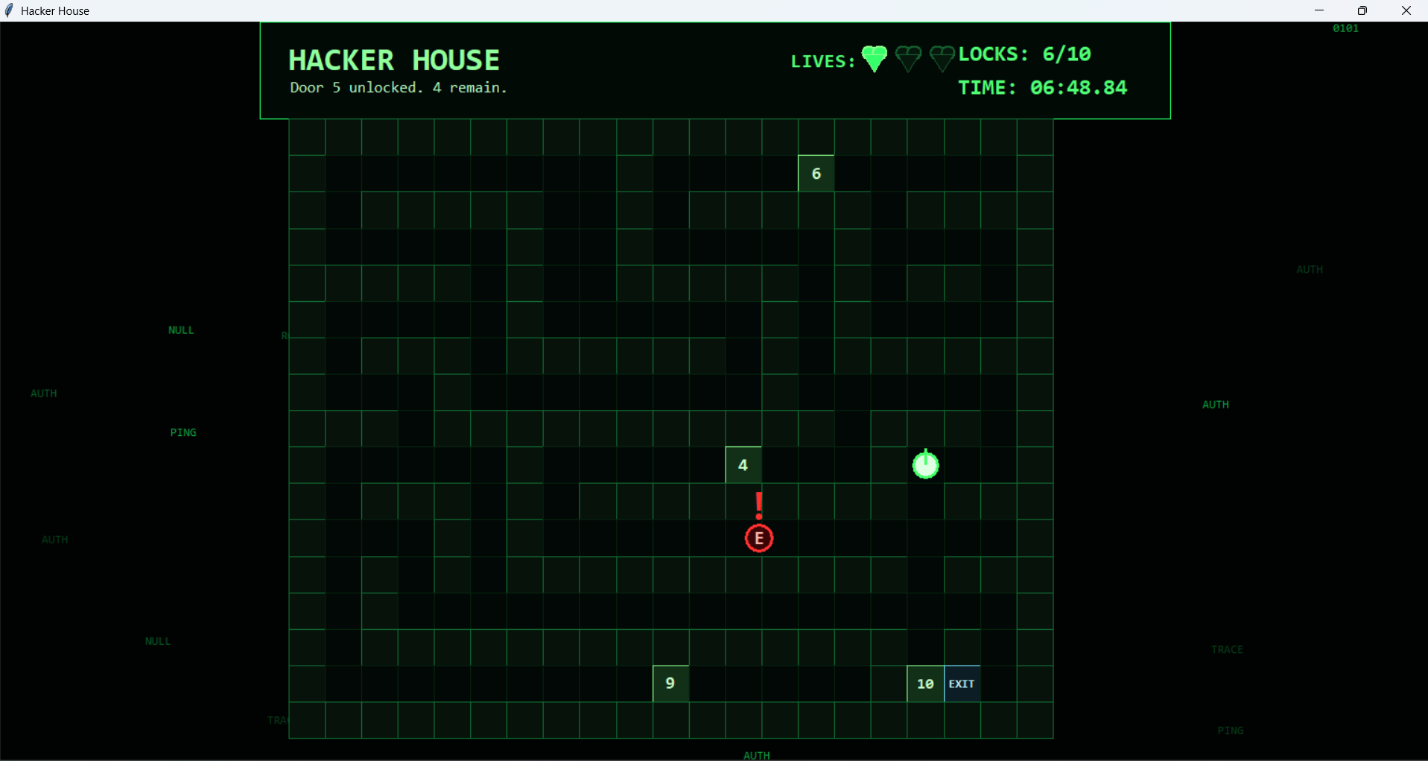
Do sound, saved-data handling and shutdown work safely? | Yes
Testing Outcome: What worked well?
Most of the intended features worked successfully, and minor issues, such as text overlapping interface elements, were straightforward to correct. The planned ideas were implemented with few difficulties, while the game’s overall theme and visual presentation were significantly improved. Features such as the main menu and How to Play screen now appear within the same application window, creating a smoother and more consistent experience than previous versions, which opened them in separate windows. The addition of completion times and a leaderboard also introduces a competitive element, allowing players to compare their results with friends.
Testing Outcome: What did not work well?
The enemy’s behaviour did not work as intended. Instead of actively chasing the player, it moves to the location of the most recently unlocked door and remains stationary until another door is opened. It also fails to react when the player is standing nearby. As a result, players are only defeated if they lose all three lives by answering questions incorrectly or directly walk into the stationary enemy. This significantly reduces the challenge and means the enemy’s pursuit system requires further improvement.

Improvements for the next version?
- Improve the games overall aesthetic
- Improve enemy ai
- Make improvements to the map
- Add a difficulty feature
- Make the game have more phases

